**SUMMER PROJECT**

**ON**

**LAB EQUIPMENT MANAGEMENT SYSTEM**

**FOR**

**DECODE GENOMICS AND RESEARCH CENTER**

**BY**

**Nischal Joshi**

**TU Registration No.: 7-2-939-62-2019**

**TU Roll No.: 10091/19**

Orchid International College

*A Summer Project Submitted to*

**Faculty of Management, Tribhuvan University**

In partial fulfilment of the requirements for the degree of

Bachelor of Information Management

Kathmandu, Nepal

July, 2023

**STUDENT DECLARATION**

This is to certify that I have completed the Summer Project entitled “Lab Equipment Management " under the guidance of “Mr. Dhiraj Kumar Jha” in partial fulfilment of the requirements for the degree of **Bachelor of Information Management** at Faculty of Management , Tribhuvan University. This is my original work and I have not submitted it earlier elsewhere.

Date: July 2023

Name: Nikhil Khanal

Signature:

**CERTIFICATE FROM THE SUPERVISOR**

This is to Certify that the summer project entitled a “Doctor Appointment Management System**”** is an academic work done by  **"**Nikhil Khanal (10088/19)” submittedin the partial fulfilment of the requirement for the degree of **Bachelor of Information Management** at Faculty of Management, Tribhuvan University under my guidance and supervision. To the best of my knowledge, the information presented by him in the summer project report has not been submitted earlier.

…………………………….

Signature of the Supervisor

Name: Er. Dhiraj Kumar Jha

Designation: Project Coordinator

Date: July,2023

**EXECUTIVE SUMMARY**

This report contains the procedure and steps of Doctor Appointment Management System for “Sukraraj Tropical & Infectious Disease Hospital”.This is an advanced and efficient platform designed to streamline the appointment booking process for patients, simplify check-in procedures, enable doctors to view and take necessary actions on appointments, and empower administrators to generate comprehensive reports. With this system, patients can easily book appointments online, reducing waiting times and enhancing convenience. Upon arrival, patients can check-in seamlessly using the system, reducing administrative burdens. Doctors gain access to their appointment schedules, allowing them to efficiently manage their time and provide prompt care. They can also take actions such as rescheduling or cancelling appointments if needed.

The technologies used to develop the system are MySQL, PHP, HTML, CSS, JavaScript and Bootstrap.

*Keyword: Doctor Appointment Management, check-in procedures, comprehensive reports*

**ACKNOWLEDGEMENTS**

This summer project report has been prepared for the fulfilment of the requirement for the degree of Bachelor in Information Management (BIM) under the faculty of Management Tribhuvan University.

It has been a great opportunity to learn and gather practical knowledge due to the University for including such a task in the curriculum of BIM. The environment of Orchid International College has been supportive in all stages of this project. Er.Dhiraj Kumar Jha, project coordinator has been supportive and inspirational to grow and develop the project.

The support of Sukraraj Tropical & Infectious Disease Hospital has been crucial and valuable with the opportunity to learn and also providing the required information of concern. The entire team of Sukraraj Tropical & Infectious Disease Hospital helped in providing the environment to complete and collect the information regarding the report.

As a whole, the direct and indirect help of all the people was valuable and crucial at different stages of the project. This outcome is the result of their support and encouragement.

**TABLE OF CONTENTS**

*STUDENT DECLARATION*……………………………………………………………...…*i*

*CERTIFICATE FROM THE SUPERVISOR*……….………………………………………*ii*

*EXECUTIVE SUMMARY*…………………………………………………………………..*iii*

*ACKNOWLEDGEMENTS*………………………………………………………………….*iv*

*LIST OF FIGURES*………………………………………………………………………..*vii*

*LIST OF TABLES*…………………………………………………………………………*viii*

*LIST OF ABBREVIATIONS*………………………………………………………………..*ix*

Chapter I Introduction…………………………………………………………….……1

1.1 Background of study……………………………………………………………………1

1.2 Introduction of the organisation………………………………………………………...1

1.3 Current Situation of the organisation…………………………………………………...1

1.4 Problem Statement of the report………………………………………………………..1

1.5 Objectives of the report…………………………………………………………………1

1.6 Literature Review……………………………………………………………………….2

1.7 Methodology……………………………………………………………………………3

1.7.1 Data and Information………………………………………………………………..3

1.7.2 Project Framework……………………………………………………………..……3

1.7.3 Tools Used………………………………………………………………………...…4

1.7.4 Technique of the project report……………………………………………………...4

1.7.4.1 Problem analysis…………………………………………………………………..4

1.7.4.2 Feasibility analysis………………………………………………………………...4

1.7.4.3 Technical analysis………………………………………………………………….4

1.7.4.4 Operational analysis……………………………………………………….……….4

1.7.4.5 Schedule analysis………………………………………………………………….4

Chapter II- Task and activities performed

2.1 Analysis of tasks………………………………………………………………………...5

2.2 Problem and issue………………………………………………………………………5

2.3 Analysis of Possible Solutions………………………………………………………….5

2.3.1 Requirement Analysis……………………………………………………………...5

2.3.2 Functional Requirements…………………………………………………………..5

2.3.2.1 Use Case Diagram………………………………………………………………………………….6

2.3.3 Non Functional Requirements…………………………………………..………..9

2.3.4 Software Requirements……………………………………………….…….…….9

2.3.5 Hardware Requirements…………………………….……………………….…..10

2.3.6 Entity Relationship Diagram……………………………………………………...11

2.3.7 Class Diagram…………………………………………………………………….12

2.3.8 Activity Diagram…………………………………………………………..………13

2.3.9 Testing………………………………………………………………………….….15

2.4 Findings………………………………………………………………………..…….16

Chapter III- Discussion and Conclusion

3.1 Discussion……………………………………….…………………………………….17

3.2 Conclusion…………………………………….……………………………………….17

3.3 Future Enhancement…………………….……………………………………………..17

References…………………………………………………………………………………18

**LIST OF FIGURES**

Figure 1.1: Waterfall Model………………………………………………………………...

Figure 1.2: Project Schedule…………………………………………………………………

Figure 2.1: Use-Case Diagram………………………………………………………………

Figure 2.2: Entity Relationship Diagram……………………………………………………

Figure 2.3: Class Diagram…………………………………………………………………

Figure 2.4: Activity Diagram………………………………………………………………

**LIST OF TABLES**

Table 1.1 Book an appointment…………………………………………………………

Table 1.2 View the available doctor…………………………………………………………

Table 1.3 Search appointment………………………………………………………………

Table 1.4 View patient record………………………………………………………………

Table 1.5 Generate Report…………………………………………………………………

Table 2.1 Software Requirement……………………………………………………………

Table 2.2 Hardware Requirement……………………………………………………………

**LIST OF ABBREVIATIONS**

Admin Administration

ER Entity-Relationship

UC Use-Case  
DAMS Doctor Appointment Management System

**Chapter I- Introduction**

**1.1 Background of Study**

The project “Doctor Appointment Management System” would input the required data of patients through a form during the booking session. The inputted data is stored in the form of a database in the server. When the user tries to validate the booking status the browser check appointment will show all their queries.

**1.2 Introduction of the Organization**

Sukraraj Tropical and Infectious Disease Hospital, located in Kathmandu, Nepal, is a prominent healthcare institution dedicated to providing specialised medical services for tropical and infectious diseases. Established in 1933, the hospital was named in honour of Sukraraj Shastri, a renowned Nepalese freedom fighter and social reformer.

**1.3 Current Situation of the Organization**

In the current situation, Sukraraj Tropical and Infectious Disease Hospital stores their data in a traditional way.This results in extra expenses and delay in operation of the information.

**1.4 Problem Statement of the report**

Sukraraj Tropical and Infectious Disease Hospital have been adapting the process of recording minute details via Microsoft office excel worksheet but in this competing surrounding, online database procedure prevails over this procedure. Through the excel sheet, everyone could have accessed data that could be confidential. Not only this but also, the excel sheet which stores minute data could be misplaced and data could be lost. It is not that the company uses and stores data carelessly by the storing of data through a website could make the work much more effective and efficient.

**1.5 Objectives of the Study**

The system aims to help the patients to take appointments online through the internet and track their records through it. The general objectives of preparing this project:

* The main objective is to develop an Online Appointment system.
* To provide a way to make appointment reservations for patients.
* To choose from different doctors with appointments available, at the time and on the day of the users’ choice.
* Make patients easy access to the system.
* To automate the report generation module.
* To computerise the patients’ information review and maintenance.
* Facilitate efficient communication between doctors and patients, allowing doctors to access appointment details and patient information.

**1.6 Literature Review**

A doctor appointment management system is a crucial tool in modern healthcare facilities, streamlining the process of scheduling and organising patient appointments efficiently. The literature surrounding this subject provides valuable insights into its benefits, challenges, and impact on healthcare delivery. One of the key advantages highlighted in several studies is the improved patient access and experience. Digital appointment booking platforms offer convenience to patients, allowing them to schedule appointments at their preferred time and location, thus reducing waiting times and enhancing overall patient satisfaction (Gupta, 2014).

Moreover, the implementation of appointment management systems has shown significant improvements in healthcare facility efficiency. By automating appointment bookings and providing real-time updates, administrative burdens are reduced, leading to better resource utilisation and optimised clinic operations (Liang et al, 2017).

This, in turn, contributes to the overall enhancement of patient care and satisfaction. Effective doctor-patient communication is another key area of focus in the literature. Appointment management systems provide doctors with access to crucial patient information before appointments, enabling personalised care and fostering better doctor-patient relationships (Wang et al, 2019).

The impact of appointment management systems on healthcare outcomes has also been examined in various studies. It revealed that optimised appointment scheduling and reduced waiting times are associated with improved patient adherence to treatment plans, resulting in better health outcomes, particularly in chronic disease management. However, amidst the benefits, the literature acknowledges certain challenges and implementation barriers. Privacy and security concerns are significant hurdles, as patient information in digital appointment systems requires robust data security measures (Kumar, 2012).

The integration of appointment management systems with existing electronic health records is a crucial consideration for healthcare organisations. The impact of seamless integration, showing that it led to improved data accuracy, streamlined workflows, and enhanced patient care coordination. (Park, 2013).

Additionally, the seamless integration of appointment management systems with existing electronic health records (EHRs) has been a focal point in the literature. The successful integration of these systems leads to improved data accuracy, streamlined workflows, and enhanced patient care coordination. As telemedicine gains prominence, some studies have explored the integration of appointment management systems with telehealth platforms. It highlighted the potential benefits of combining appointment scheduling with telemedicine services, particularly in improving healthcare access for remote and underserved populations.(Chen, 2018) .

**1.7. Methodology**

Methodology in terms of software development refers to the systematic and structured approach used by software development teams to design, build, test, and deliver software products or applications. It outlines the processes, practices, and guidelines that developers and project stakeholders follow to ensure the successful and efficient completion of the software development project.

**1.7.1 Data and Information**

Primary method of data collected was used for gathering information. The organisational visit was administered to the Director of Sukraraj Tropical and Infectious Disease Hospital, and there was a positive response from the director in terms of questions related to the project.

**1.7.2 Project Framework**

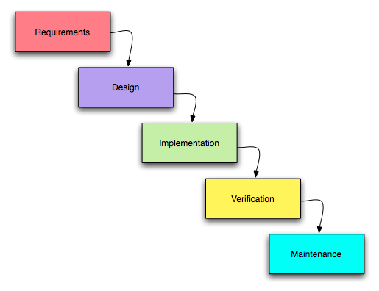

*Fig 1.1: Waterfall Model*

The reason behind considering this methodology is as follows:

* Every step and requirement is defined before design.
* Easier to understand and implement.
* No ambiguous requirement in development and implementation.
* It has clear milestones and is easy to predict.

**1.7.3 Tools Used**

Database: MySql

Language: HTML, CSS, PHP

Server: Xampp

Text editor: Visual Studio Code

**1.7.4 Technique of the project report**

**1.7.4.2 Problem analysis**

The main problem of the organisation is that they didn’t have a computerised system to maintain records digitally.This involves gathering information on the existing systems, identifying their limitations, and proposing potential technical solutions.

**1.7.4.3 Feasibility analysis**

In the feasibility analysis, you will assess the technical feasibility of the project. This includes evaluating whether the proposed solution is achievable within the given technological constraints and resources.The analysis of the project has led to the conclusion that the project is feasible with time and cost. The tools used for development are almost Open Source and involve less cost and maintenance.

**1.7.4.4 Technical feasibility**

This analysis helps to forecast the future movement.The technical analysis will require you to thoroughly assess the proposed technical solution.Technical feasibility evaluates whether the proposed web-based application can be developed using the available technology stack and resources. I am using Visual Studio Code to develop the project.

**1.7.4.5 Operational feasibility**

In this analysis the system is analysed on how well the proposed system solves the problem, and works in the real environment and how it satisfies the requirement analysis phase of the system development.This may include evaluating the integration of the new solution with existing systems, data migration, and potential disruptions during deployment

**1.7.4.6 Schedule feasibility**

The analysis of this project has led to the conclusion that the project is feasible with time as it can be completed with the given time frame including all the criteria and the features.

|  |  |
| --- | --- |
| **Task** | **Duration** |
| Project Planning | 1 week |
| Research Study | 2 weeks |
| Collecting Information | 2 weeks |
| Coding & Design | 4 weeks |
| Unit Testing | 3 weeks |
| Deployment | 1 week |

TOTAL DURATION: 13 weeks

*Figure 1.2: Project Schedule*

**Chapter II- Task and Activities Performed**

**2.1 Analysis of tasks**

Different websites were visited for the requirement collection.After the requirements were collected, the major task was to break down the proper procedure and build the working framework. Organisation visit helped to analyse various aspects of the organisation and find out the problems that can be solved by the software build.

**2.2 Problem and issue**

After the brief analysis of the task and requirement. I found out the problem in the organisation in which I can help them to overcome it. The organisation mainly works on the traditional file system where I found the major problem. So, the company wants software to make it easy for users to use them.

**2.3 Analysis of Possible Solution**

**2.3.1 Requirement Analysis**

The main objectives of requirement analysis are to identify and evaluate the requirement of the proposed system. It helps to know about user requirements, system requirements, functional requirements, and non- functional requirements for DAMS for Sukraraj Tropical & Infectious Disease Hospital.

**2.2.2 Functional Requirements**

A functional requirement is a description of the service that the software must offer. It describes a software system or its components. A function is nothing but inputs to the software system, its behaviour, and outputs. It can be a calculation, data manipulation, business process, user interaction, or any other specific functionality which defines what function a system is likely to perform. Functional requirements are also called functional specifications. Functional requirements can range from the high-level abstract statement of the sender's necessity to detailed mathematical functional requirement specifications. Functional software requirements help you to capture the intended behaviour of the system. It describes the functions of a system and its components. The DAMS for Sukraraj Tropical & Infectious Disease Hospital shall contain the admin who could be able to view the details of patients, doctors, appointments. Functional requirements can be briefly described with the help of Use Case Diagram which is shown below:

**2.3.2.1 Use Case Diagram**

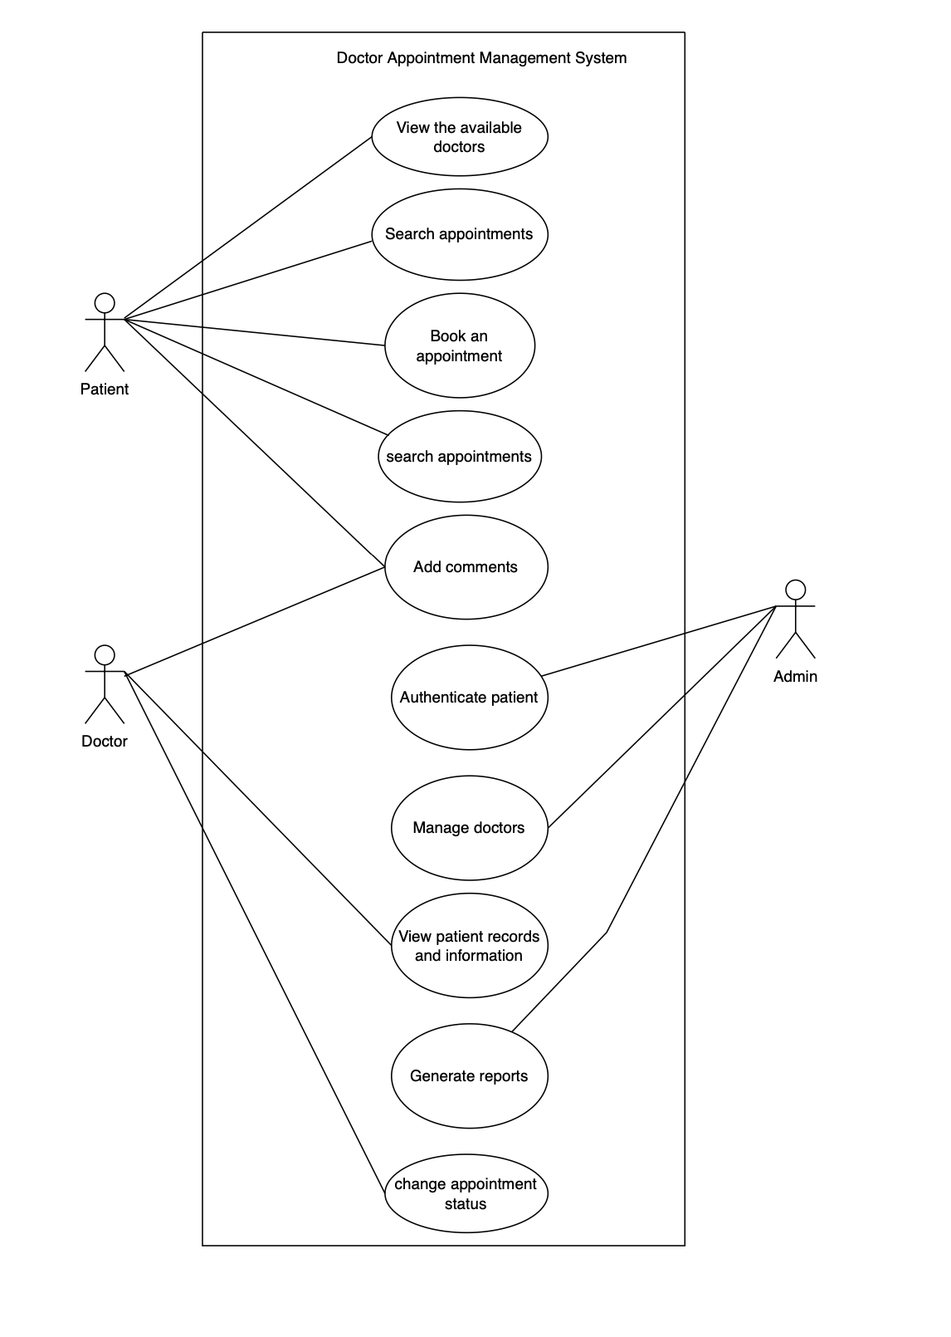

*Figure 2.1: Use Case Diagram of Doctor Appointment Management System*

Table 1.1: Book an appointment

|  |  |
| --- | --- |
| Use-case Identifier | UC-101:Search by patient |
| Primary Actor | Patient |
| Secondary Actor | Admin |
| Description | The patient is able to book the appointment according to the schedule. |
| Pre-condition | The patient or user must be logged in. |
| Post-condition | Booking of the appointment is done by the patient. |
| Failure scenario | If booking is done on the same appointed schedule, booking will fail. |

Table 1.2: View the available doctors

|  |  |
| --- | --- |
| Use-case Identifier | UC-102:Search by Doctor |
| Primary Actor | Patient |
| Secondary Actor | Null |
| Description | The patient is able to view the doctors that are present in the organisation. |
| Pre-condition | The patient /user must be logged in.. |
| Post-condition | The patient can view the available doctors according to the prescription they want. |
| Failure scenario | Doctors not available for the time being can’t be viewed. |

Table 1.3: Search appointment

|  |  |
| --- | --- |
| Use-case Identifier | UC-101:Search by appointment |
| Primary Actor | Patient |
| Secondary Actor | Null |
| Description | The patient is able to view the appointment. |
| Pre-condition | The patient or user must be logged in. |
| Post-condition | The patient can view the appointment status marked by the doctor. |
| Failure scenario | If there is no booking no appointment will be shown. |

Table 1.4: View the patient records

|  |  |
| --- | --- |
| Use-case Identifier | UC-102:Search by Doctor |
| Primary Actor | Doctor |
| Secondary Actor | Admin |
| Description | The doctors and admin are able to view the information of the patients |
| Pre-condition | Both doctors and admin must be logged in.. |
| Post-condition | Doctors and admin can view the records of patients and act accordingly. |
| Failure scenario | Doctors not available for the time being can’t be viewed. |

Table 1.5: Generate report

|  |  |
| --- | --- |
| Use-case Identifier | UC-102:Search by Doctor |
| Primary Actor | Null |
| Secondary Actor | Admin |
| Description | The admin can generate reports from starting to end date. |
| Pre-condition | The admin must be logged in.. |
| Post-condition | The admin can view all the patient's appointments from start to end date. |
| Failure scenario | The date must be greater than todays. |

**2.3.3 Non Functional Requirement**

Non-Functional Requirement specifies the quality attribute of a software system. They judge the software system based on responsiveness, usability, security, portability, and other non-functional standards that are critical to the success of the software system. DAMS will be easier to use with better GUI. The non functional requirements for the project are as follows:

* **Security** The system implementation was done in JavaScript Programming language which has its own security system. The authorities are provided according to the roles. Validations are imposed to prevent any unauthorised access.
* **Safety** The project does not have any direct physical harm to the users.The project is safe to use as it gives data confidentiality, availability and authorization to all of its users.
* **Backup** The database may get crashed at any certain time due to operating system failure so it is required to take the database backup.
* **Performance** The system is expected to perform effectively and efficiently. It should be able to provide fast and optimal performance in a cost-effective way.

**2.3.4 Software Requirements:**

|  |  |
| --- | --- |
| IDE | Visual Studio Code |
| Design | Figma |
| Diagrams | draw.io |
| Server | XAMPP, MySQLServer |
| Browser | Google Chrome, Safari |

*Table 2.1: Software Requirement*

**2.3.5 Hardware Requirements:**

|  |  |
| --- | --- |
| Operating System | Windows 8 |
| Processor | 2.13 Ghz |
| RAM | 8 GB |
| Disk Space | 5 GB minimum |
| Device | PC, Laptop, Android Device |

*Table 2.2: Hardware Requirement*

**2.3.6 Entity Relationship Diagram**

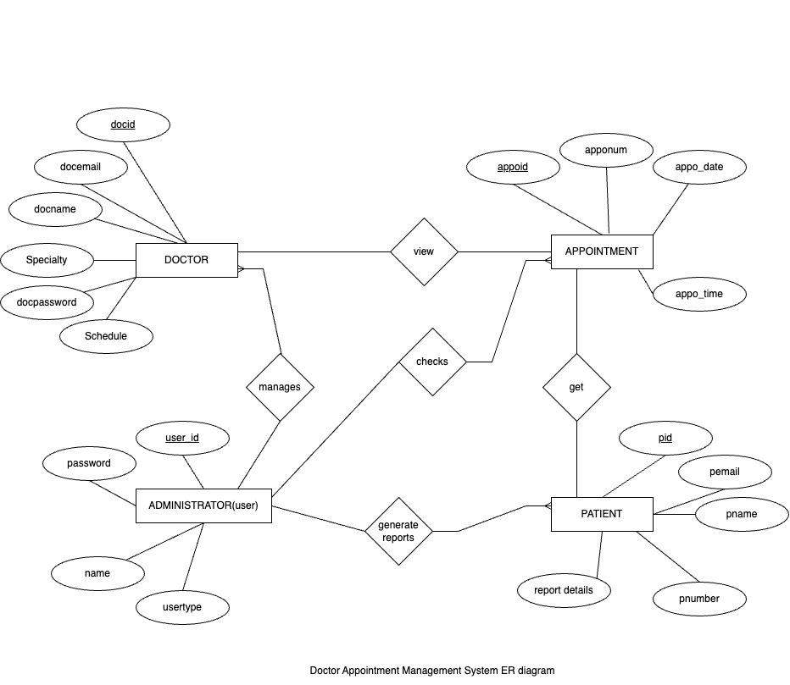

*Figure 2.2: Entity Relationship diagram of DAMS*

**2.3.7 Class diagram**

A class diagram is a type of UML (Unified Modeling Language) diagram that represents the static structure and relationships among classes in an object-oriented system or software application.

Class Diagram of DAMS is represented below:

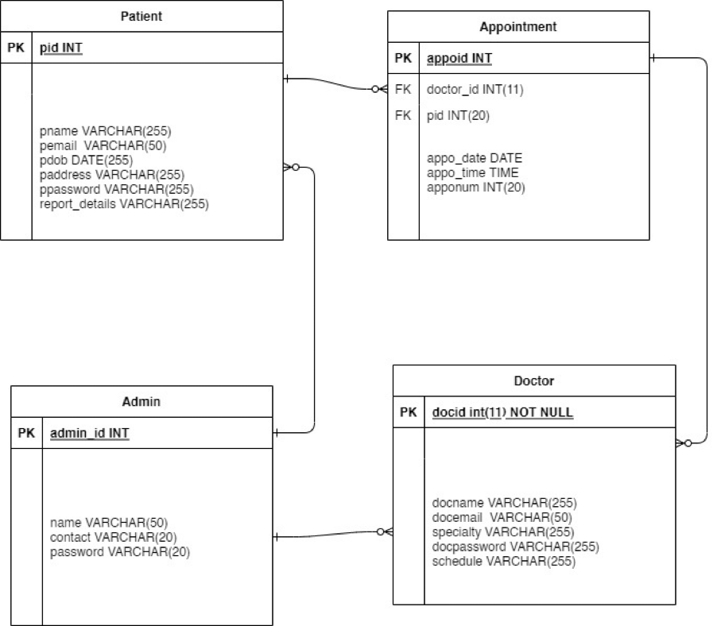

*Figure 2.3: Class diagram of DAMS*

**2.3.8 Activity Diagram**

* Book an appointment

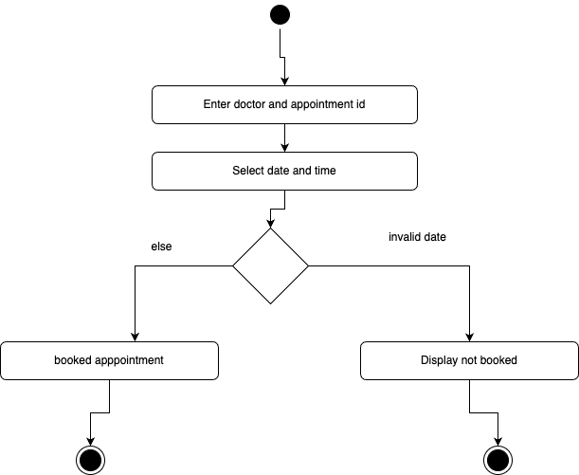

* View the available doctors

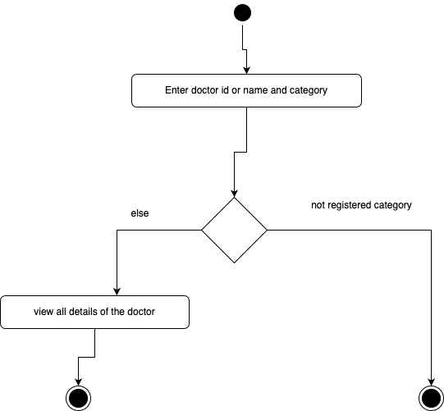

* View the patient records

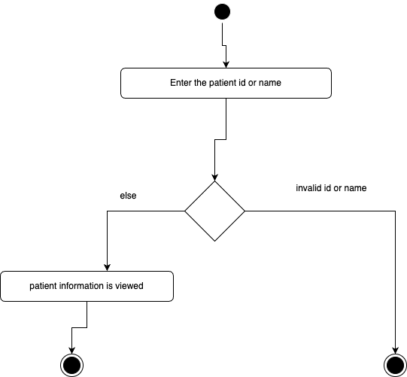

* Authenticate patient

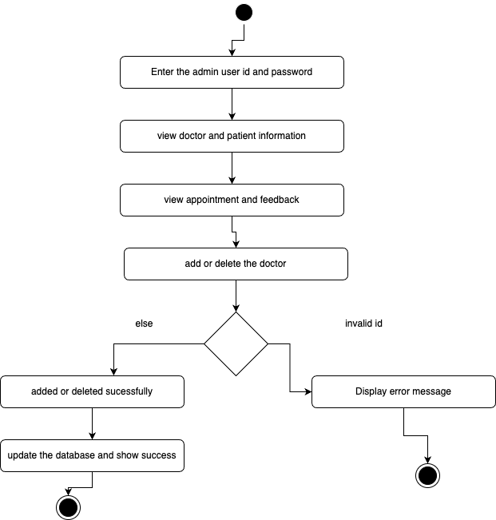

*Figure 2.4: Activity Diagram*

**2.3.9 Testing**

In testing, the different inputs were tested as input to GUI forms which can is shown below with the help of table as well as figure:

Testing Table for Login:

|  |  |  |  |  |
| --- | --- | --- | --- | --- |
| Unit effected | Test input data | Actual result | Expected result | Remarks |
| Doctor login | Username=doctorPass  word=doc | Error: “Password is  required” | Logged in | Fail |

Testing table for booking an appointment:

|  |  |  |  |  |
| --- | --- | --- | --- | --- |
| Unit effected | Test input data | Actual result | Expected result | Remarks |
| Book  appointment | Name= Username= Gender =  Select date and time= | Field is  empty | Field is  empty | Pass |

Testing table for user registration:

|  |  |  |  |  |
| --- | --- | --- | --- | --- |
| Unit effected | Test input data | Actual result | Expected result | Remarks |
| User registration | Username=uname  word=usr | User registered | User should be registered | Pass |

**2.4 Findings**

The findings after analysing the previous system in the organisation had only increased cost and difficulty in handling. So, to cut out the unwanted cost and ease the administration process effectively this mobile application will be a great help to the organisation. It will help them to maintain record and efficiently with reduction in cost.

**Chapter III- Discussion and Conclusion**

**3.1 Discussion**

The project covers the problem that was identified during the organisation visit and the solution to the problem was solved by developing software. The system can provide information about doctor, patient and appointment management etc related to Health Care. The system is assumed to be very helpful to the Sukraraj Tropical and Infectious Disease Hospital.

**3.2 Conclusion**

The system was successfully completed in time as per the objectives. After the evaluation of the system within the Sukraraj Tropical and Infectious Disease Hospital, the system is expected to fulfil all the requirements and prove to be beneficial for admin. The evaluation from users of this system in Sukraraj Tropical and Infectious Disease Hospital proved that the system would turn out very effective and convenient to use. The waterfall model used in this system is helpful to check in every phase after each coding.

**3.3 Future Enhancements**

This project was started with the aim of keeping systematic records of students admitted. The system was successfully built and is said to be kept updated with the resources available and keep records for future uses,which helps to maintain accountability.

**References**

Best doctor appointment management software an overview: https://mopinion.com/top-20-best-doctor-appointment-management-software-an-overview/#:~:text=Doctor%20Management%20Software%20is%20software,documentation%20exchanged%20throughout%20a%20project.S. L. (2010).

Doctor appointment management system: https://en.wikipedia.org/wiki/Doctor_appointment_management_system

Doctor management system definition example: https://study.com/academy/lesson/doctor-management-system-definition-example.html#:~:text=A%20doctor%20management%20system%20is,Cost%20control%20and%20budget%20management

Sommerville, I. (2011). Software Engineering ninth edition. Pearson Education Inc. https://pdfs.semanticscholar.org/b50d/1a39b9b65912268ae0e65a64bad87c1ad184.pdf https://www.wikiwand.com/en/Hea

You’re losing money by not using doctor management software:- https://blog.proofhub.com/youre-losing-money-by-not-using-doctor-management-software-b0664936ff5e

**Appendices**

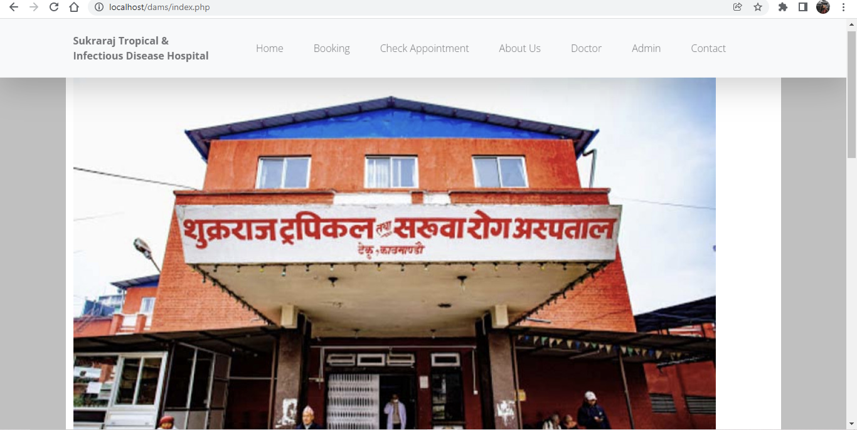

Home Page

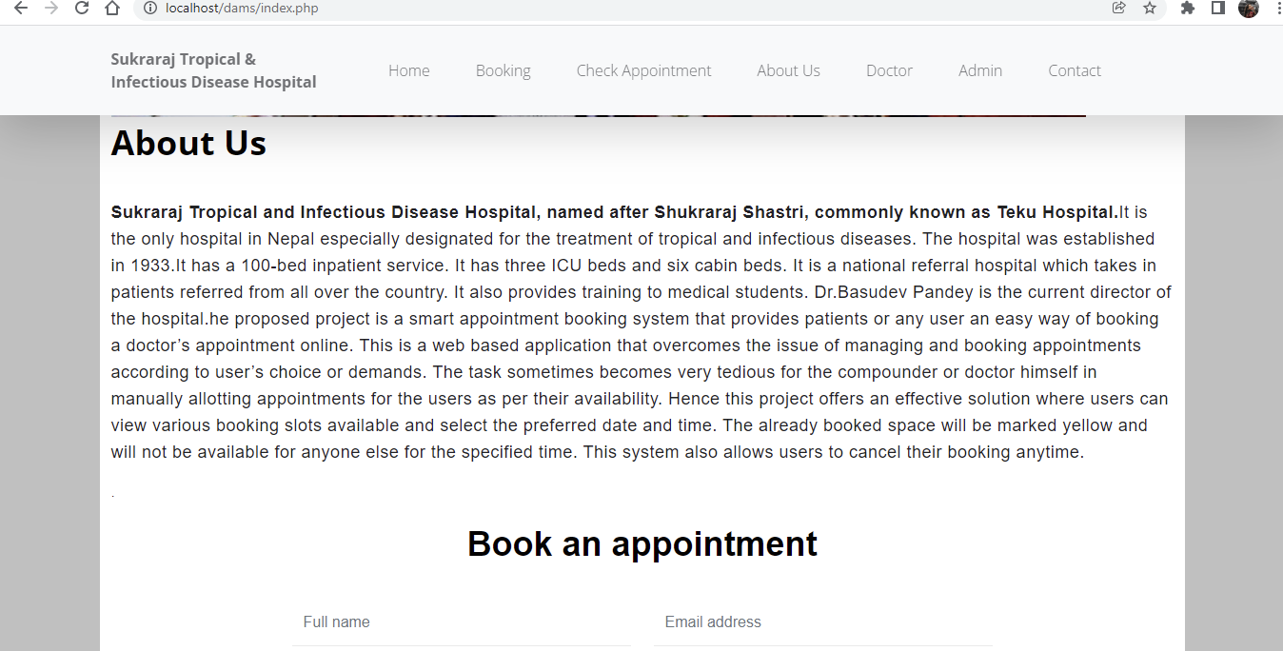

About Us

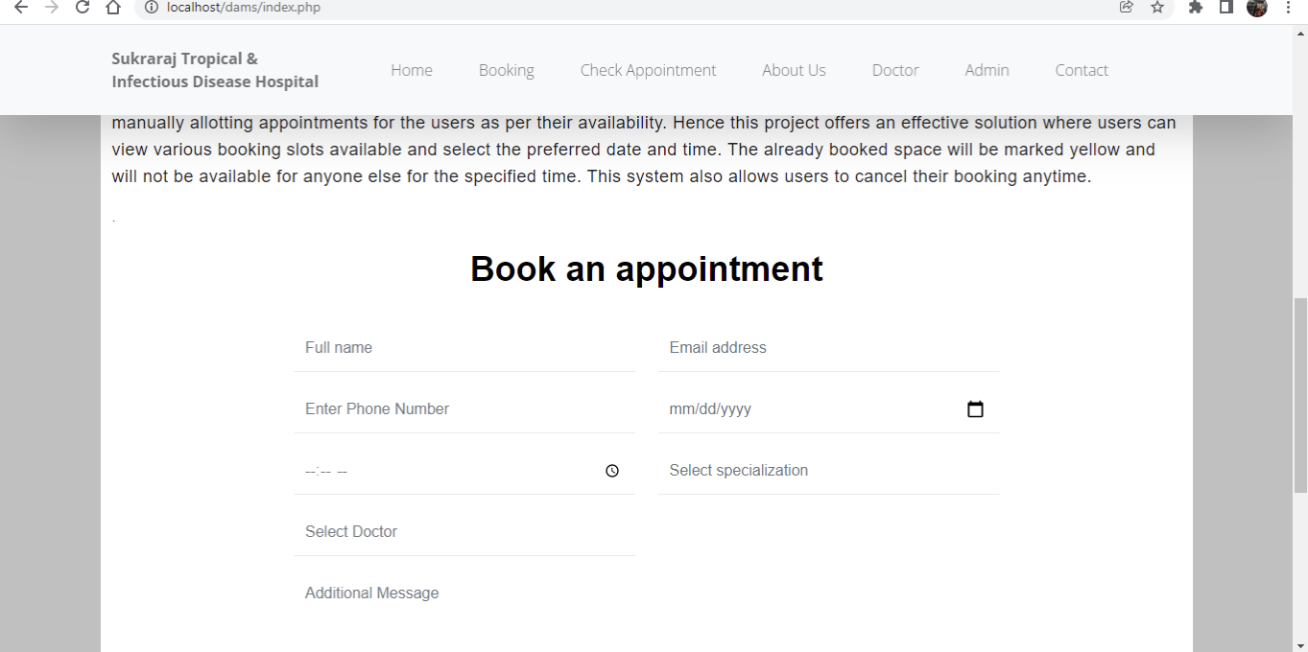

Book an appointment

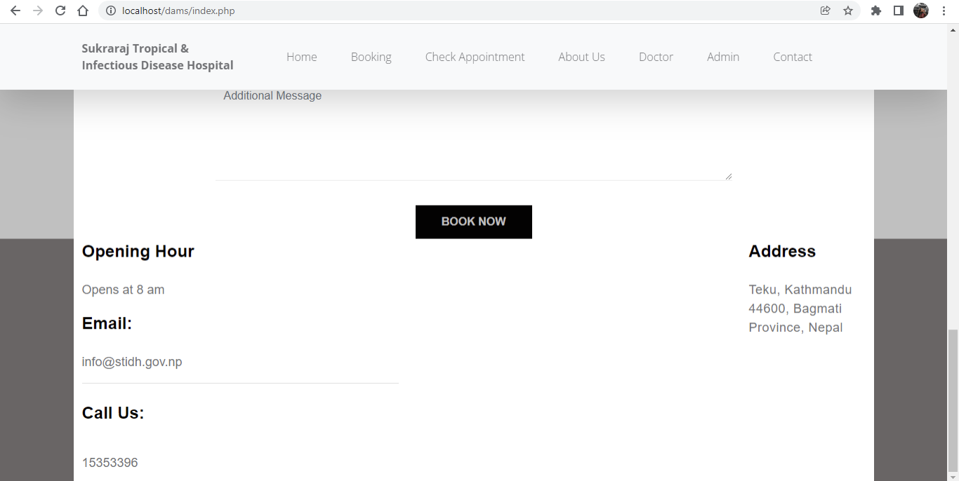

Contact Information

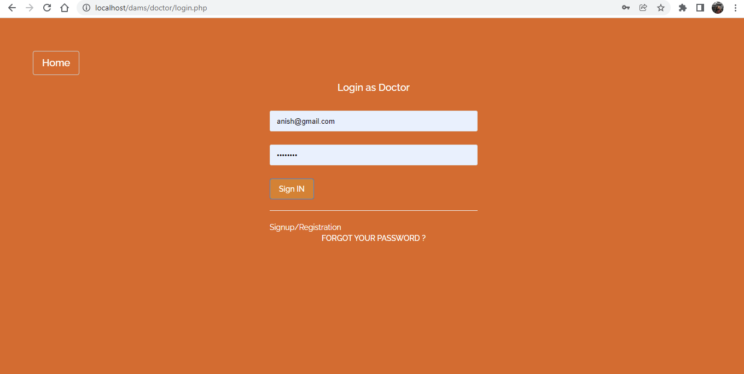

Login as Doctor

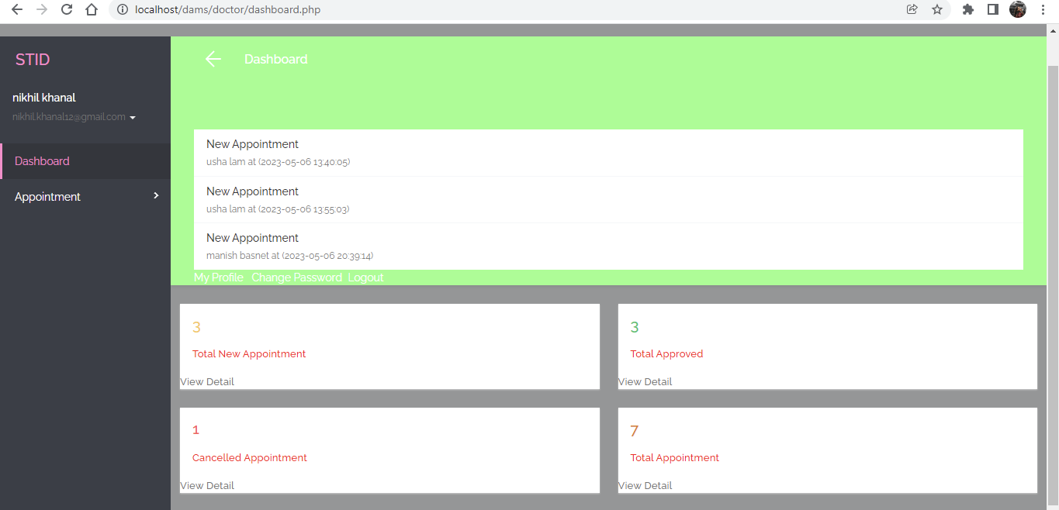

Dashboard of Doctor

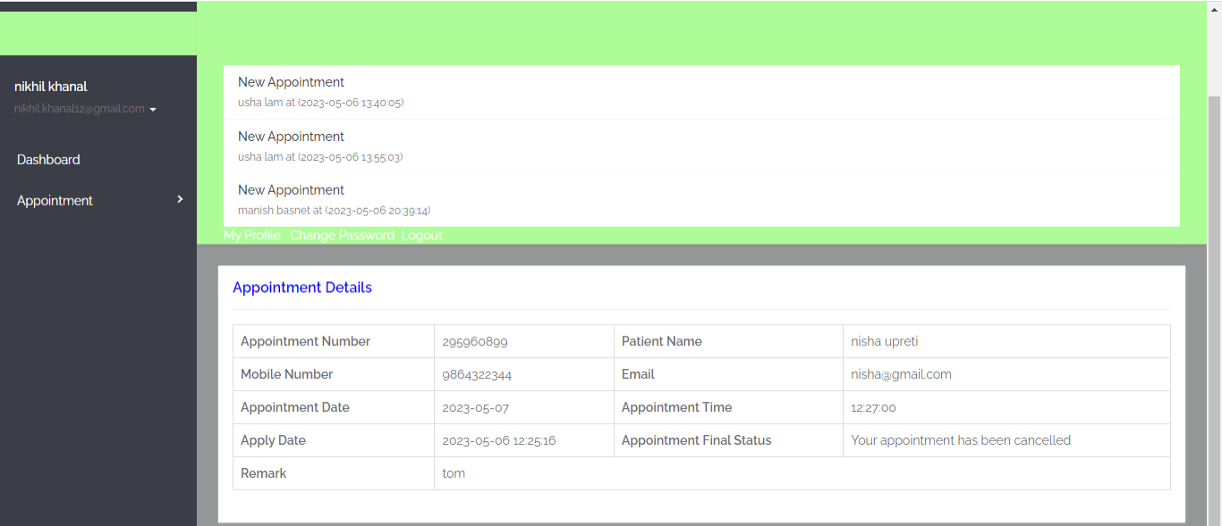

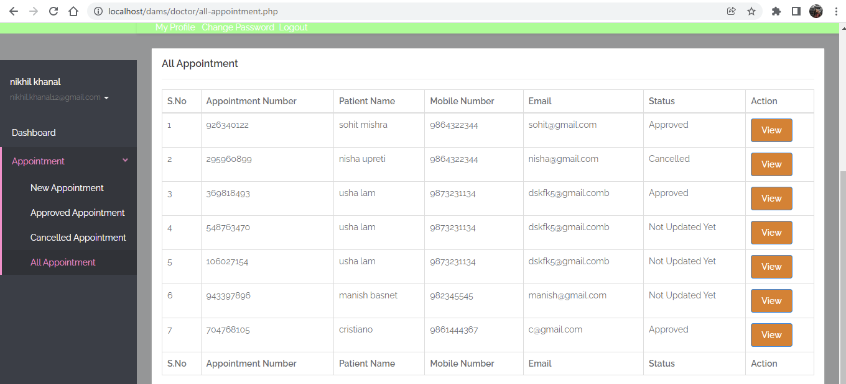

Appointment Details

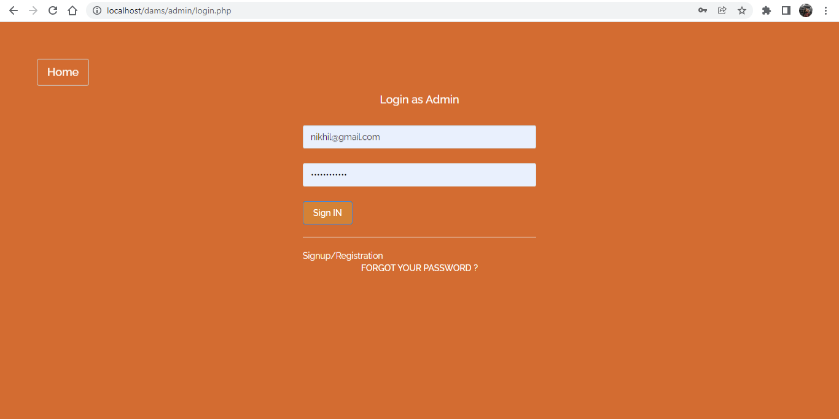

Login as Admin

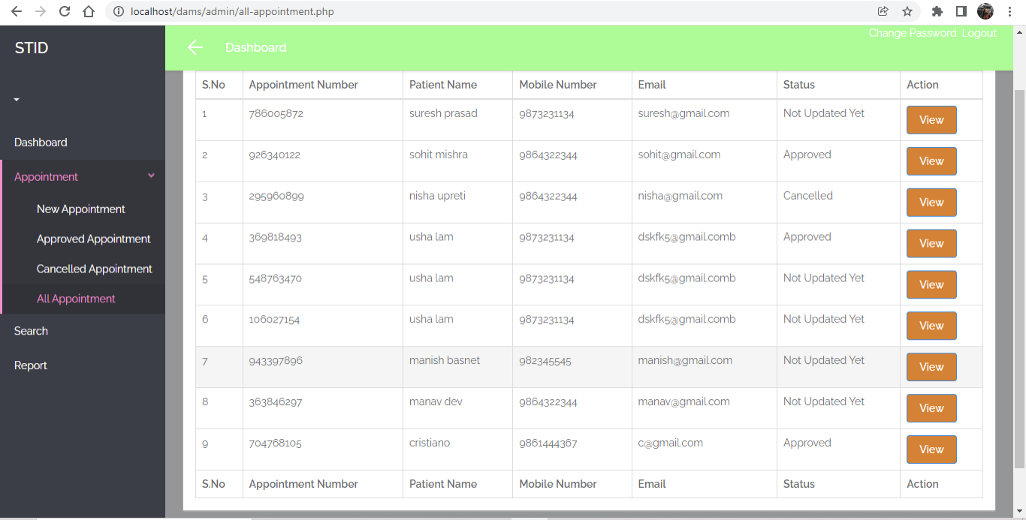

Appointment List

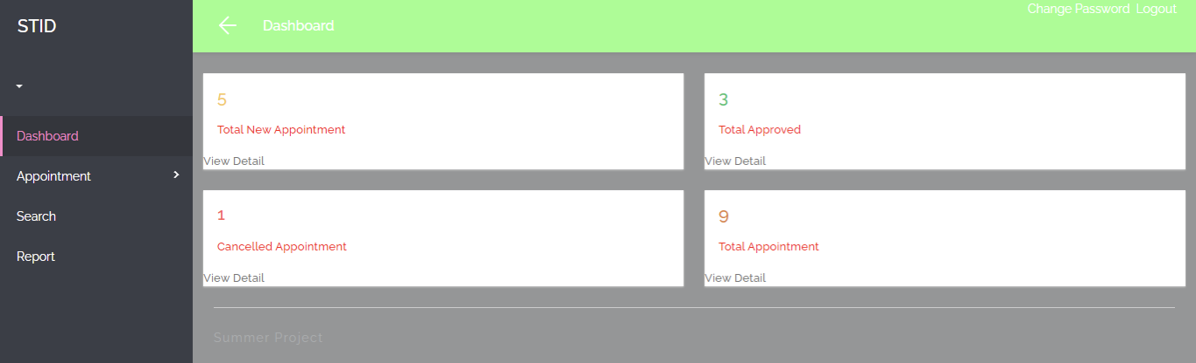

Dashboard

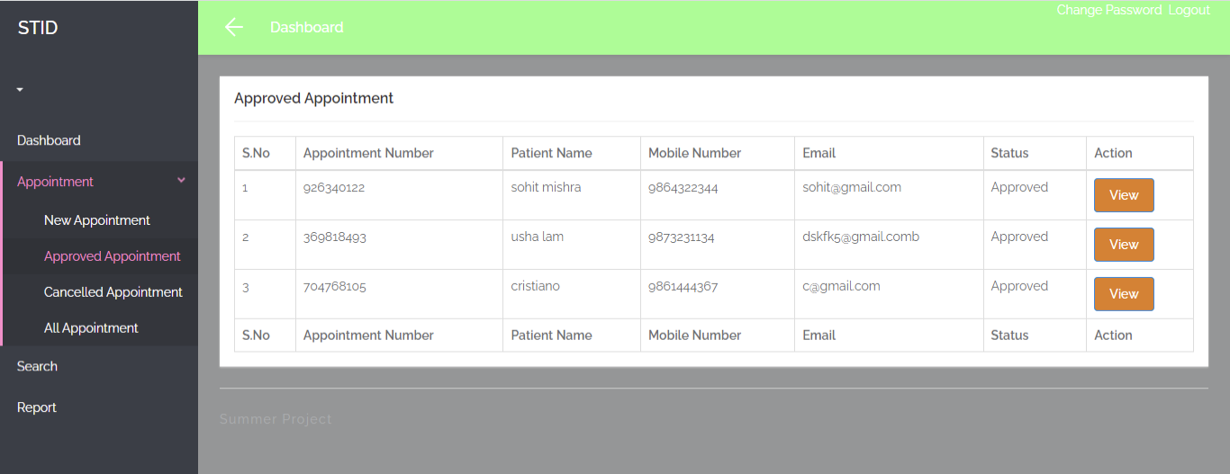

Appointment Details